**1. RESEARCH PROJECT - Post Lab Report:**

1. **Purpose**: The purpose of this experiment is to vary the current (I) from .5A to 3A at half amp increments. Theoretically, magnetic field(B) is linearly proportional to current(I). Increasing current should increase the magnetic field directly. However, this experiment will show that other factors not accounted for within Biot-Savart’s law will break the linear relationship between magnetic field(B) and current(I). The prediction for this experiment is that current will begin to create heat(W) as the carrying capacity of the 24 AWG wire restricts the flow of current with the internal resistance(Ω) of the coil.
2. In theory, Biot-Savart’s law shows that the magnetic field in Teslas along the x-axis through the center of a current carrying loop is:

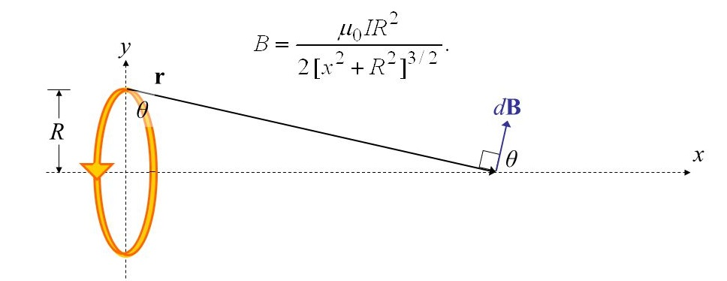

**Figure 1**

1. This experiment uses an inductor of radius 1cm and 475 turns. This can be multiplied to the formula in figure 1 to increase the magnetic field strength by a factor of 475.

**2. System Design:**

A. This experiment uses a platform containing the hall effect sensor which measures the magnetic field (B) along the x-axis. The platform moves with precision driven by a stepper motor along a carbon fiber track. The sensor moves along the x-axis 8cm from the coil, 4cm through the coil, and then 8 cm on the other side as seen in figure 2. The software maintains the origin of the system at the center of the coil.

B. The software written in python controls the stepper motor and allows the embedded device to control an analog to digital converter via I2C protocol. This analog converter (ADC) receives a signal from the hall effect transistor used to measure the magnetic field(B) and conditions the signal with a gain amp. This amplifier has an adjustable resistor that allows for calibrating the gain factor.

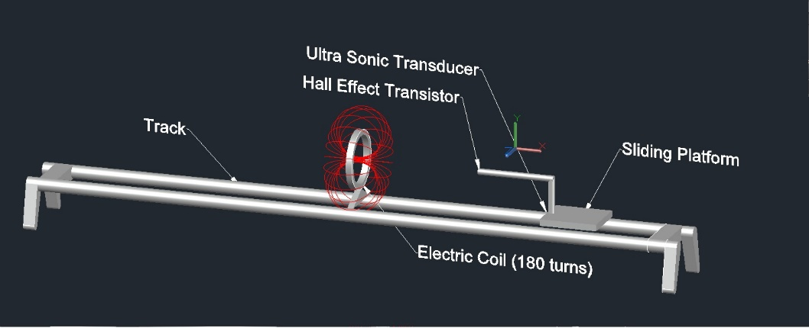

Figure 2

C. To minimize signal loss and increase gain, the sensor amp, analog-to-digital converter (ADC) and Raspberry Pi (embedded device) are interconnected with a PCB board created by etching copper traces with photoresistant film and ferric chloride. The result is a customized PCB board that interconnects all devices.

D. The coil is supplied with current from a current controlled current supply (CCCS) supplied by GRCC Physics department.

E. The coil is wrapped around a PLA extruded object designed on Autocad and printed with a 3d printer. This also proves to be a design flaw as the PLA extruded material melts at 185oC and the purpose of the experiment is to show how energy transferred to heat lowers the magnetic field.

F. Using magnetic modeling software (FEMM), an analysis can be done of the solenoid used as seen in Figure 3 and Figure 4. This models the density gradient of the magnetic field produced by 475 turns of wire and 1A of current running through the coil. The figure is a cross section view of the coil.

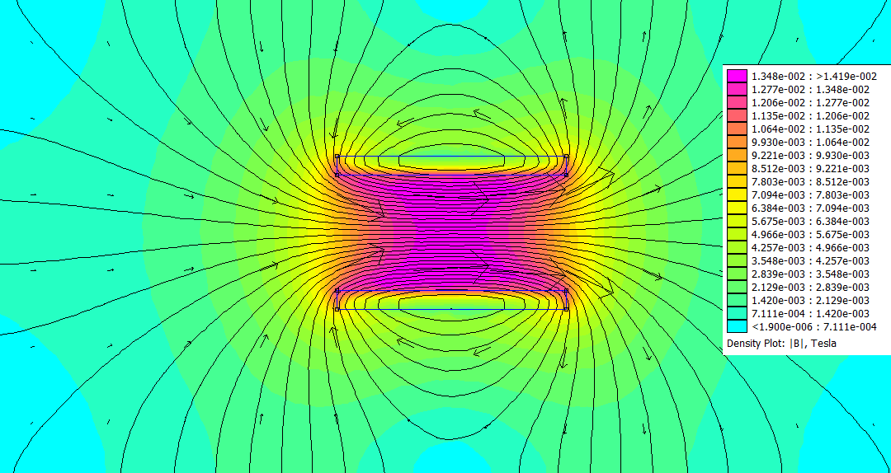

Figure 3

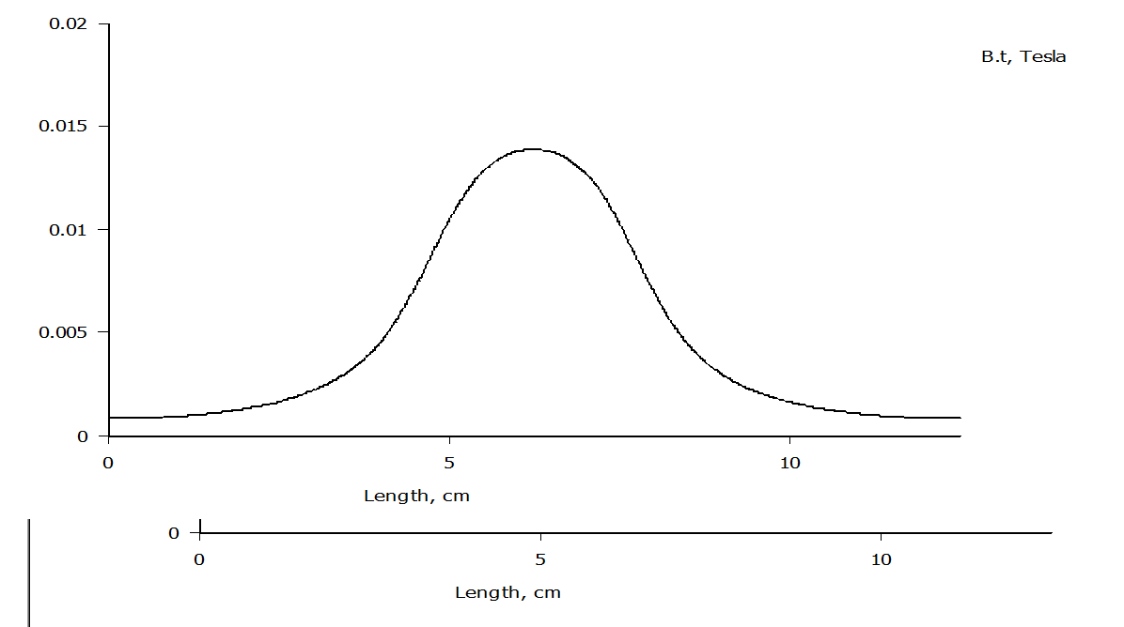

Figure 4

**3. Procedure**

A. The procedure involves initiating the software and gathering the values for the magnetic field (B) along the axis. The software captures magnetic field over distance.

B. Between each trial the current is incremented by a half amp.

C. The following data plots display the magnetic field over distance.

C. Data:

**Trial 1: .5A** Figure 5

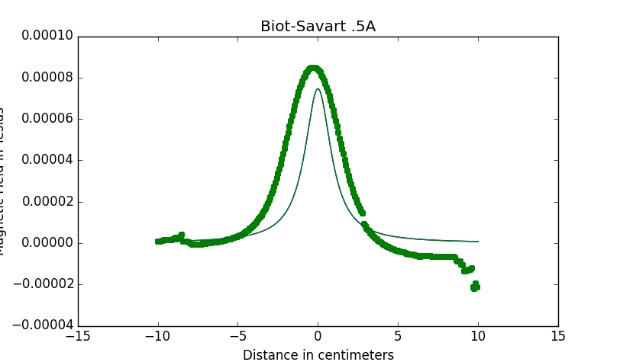

**Trial 2: 1A** Figure 6

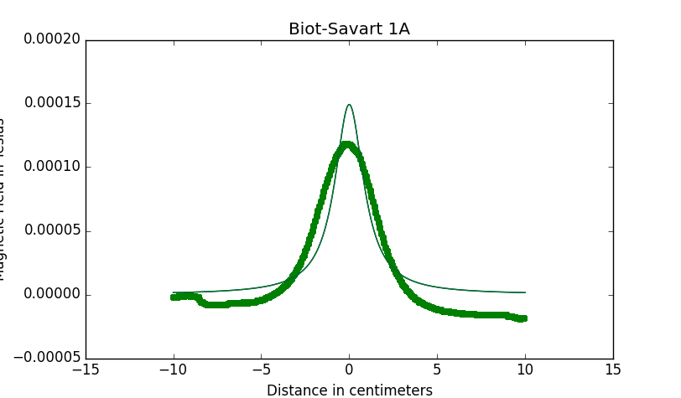

**Trial 3: 1.5A** Figure 7

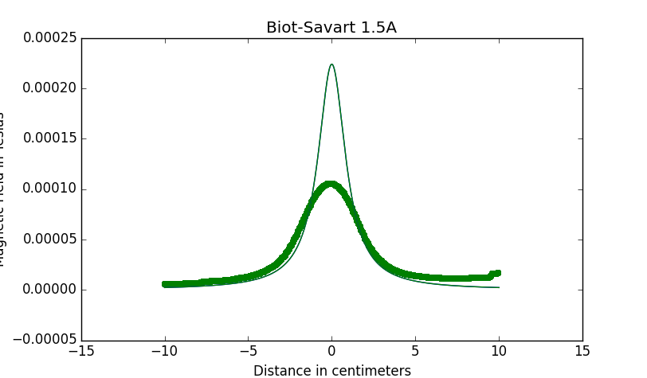

**Trial 4: 2A** Figure 8

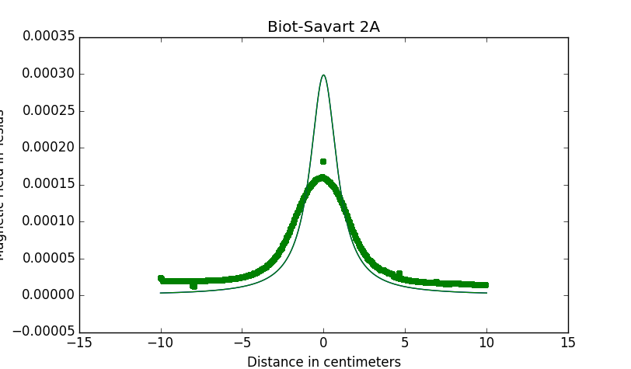

**Trial 5: 2.5A** Figure 9

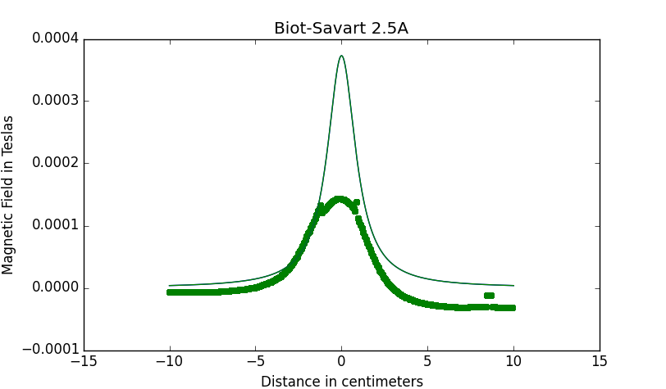

**Trial 6: 3A** Figure 10

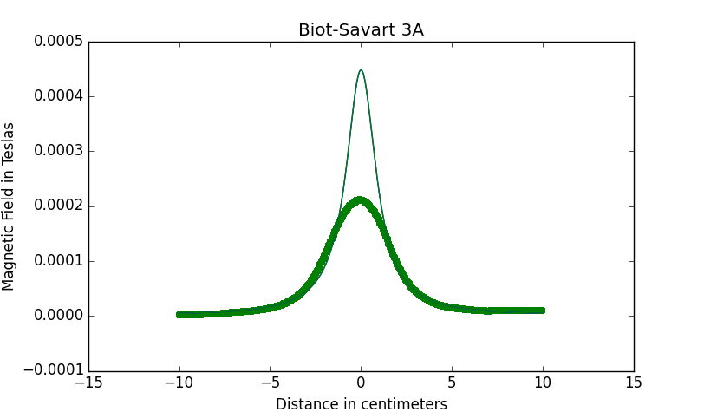

**4. Analysis:**

A. The results of this project produced data that accurately represented the magnetic field along the x-axis according to Biot-Savart’s law. Although the hall effect sensor is not calibrated with an acceptable industry standard, it produced a graph and data that can be analyzed on a macro scale. Namely, the curve from figures 5-10 clearly show that the magnetic field does not increase at the same rate it should theoretically. (Scatter plot or thick green line is experimental data and solid line thin line is theoretical data)

B. The energy lost to heat is a physical property captured with Ohm’s law: P = VI or P = I2R. This bifurcation occurs at as the current carrying capacity of the wire is reached and the energy is split between the magnetic field and the heat produced.

C. It is important to note from the graph of the largest magnetic field strength taken over each trial (Figure 11) does show a linear relationship. Contrary to the predicted outcome, this linear relationship exists between current values used. It may diverge to an equilibrium if greater currents were used and the experiment was extended to current exceeding 10A. The linear relationship shown below may be a direct reflection of the resistance which was measured to be at 9Ω over the length of the wire used.

Figure 11

**5. Results:**

A. The final conclusion from this research project is that producing a magnetic field depends on more factors than what Faradays law or Biot-Savart’s law would suggest. The shape of our graphs suggest that the field strength at various distance matches Biot-Savart law with precision, but uncalibrated test equipment largely contributed to the loss of accuracy.

B. As the coil did get hotter (to touch) after larger current were used, the B field did fall short of the theoretical value, but not exponentially as predicted. Instead, Figure 11 suggest that a constant factor causes the reduction in magnetic field strength which is linear in nature. It can be assumed that this constant is the inherit resistance of the wire which is not accounted for in Biot-Savart’s law.

C. Experimental Error: It should be noted that the experimental error in this experiment is too large. Since the hall effect sensor is relative to the property of the circuit that gains the value, it is difficult to accurately calibrate the sensor without an advance laboratory. Instead, the sensor was loosely calibrated against the physics department’s magnetic field sensor. Despite this, the curve produced still follows the theoretical values well.